**Dr. Kathleen Mojas**

**Website: DrKathleenMojas.com Instagram: traumawhisperer**

# 4 Fast Techniques and 2 Daily Practice’s

**We all need to take 100% responsibility for taking control over our state of mind and being the best version of ourselves…**

1. ***Awareness*: Recognize when you are triggered.**

**Too Angry, anxious, stressed or sad. Are you engaging in unhealthy coping?**

1. ***Hit the pause button*. Stop! If you are triggered do not try to resolve an issue until your adult problem solving mind is back online.**
2. **Do 5 minutes of nasal breathing or nasal humming.**
3. **Open your peripheral vision or do lateral eye movements.**

# 2 Daily Practice’s

1. **Keep a daily gratitude journal. Write 3 things you appreciate in the morning and 3 things every evening followed by heart coherence breathing.**
2. **Heart coherence breathing. 5 minutes in the morning, midday and evening in order to optimize heart rate variability and stress resilience.**

**Dr. Kathleen Mojas**

**Website: DrKathleenMojas.com**

**Instagram: traumawhisperer**

**Heart Coherence Breathing**

1. **Focus on a feeling of appreciation, gratitude, compassion or love for anything or anyone, including yourself.**

1. **Breathe in and out to the count of 5 through your nose.**

1. **Focus your awareness on your heart and imagine you are breathing in and out through your heart for 5 min.**
2. **As you breathe out you may choose to feel and send love or healing to someone or something you care for or appreciate. Otherwise, just feel the emotions of love, compassion, and appreciation as strongly as you can. This creates a coherent heart rate, brain waves and an EMF signal that is broadcast to every cell in your body and out into the space around you.**

**(When you finish you may choose to do step 5)**

1. **If you are dealing with a stressful situation or have been in conflict with anyone, ask a question from the heart… What can I do to improve this situation? To have a more balanced perception? To minimize the stress in this situation? You may receive validation of something you already sense or you may get a complete shift in perspective and see things in a more balanced way.**

**\*Sense how your heart space has grown larger. More energy, blood flow and oxygen are now flowing through your heart.**

**Benefits Of Heart Coherence Breathing**

**Your body is better than any pharmacy. With every emotion good or bad you release a cascade of over 1,400 chemical reactions. When you do Heart Coherence breathing with**

**elevated positive emotions as a daily practice, you elevate your**

**heart rate variability and these are the benefits…**

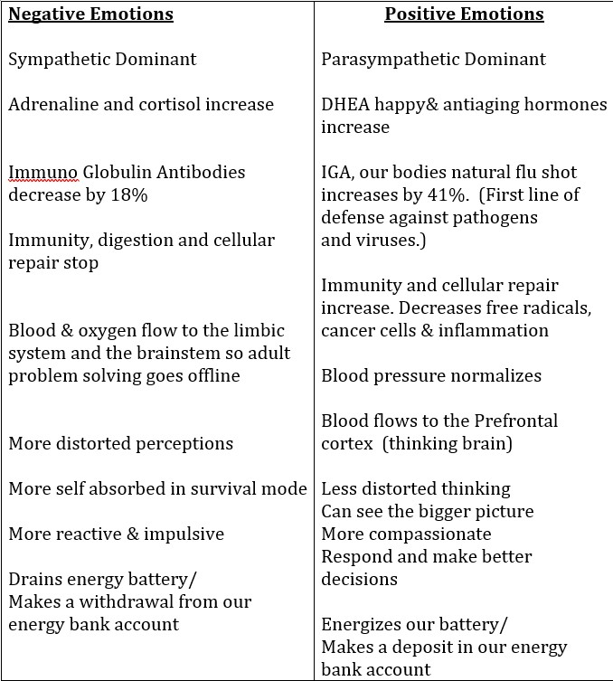

**(**

**IGA**

**)**